What is Hypothesis testing?

What is simple Hypothesis testing?
In ML, a hypothesis is simply:
"A guess your model makes to predict output"

Think of it this way
Input Features:
├── Size = 1500 sq ft
├── Rooms = 3
└── Location = City

Model's Hypothesis:
"I think this house costs $200,000"

The model is basically saying:
"I THINK if these inputs come in, this will be the output"

Real Ml example:
Input Features:
├── Size = 1500 sq ft
├── Rooms = 3
└── Location = City

Model's Hypothesis:
"I think this house costs $200,000"

Hypothesis Ml Algorithms:
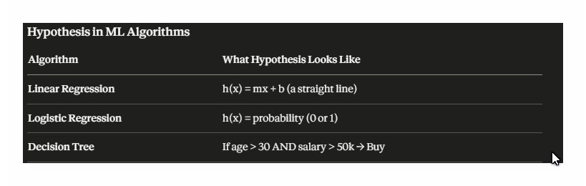
How ML finds the best Hypothesis
Step 1 → Model makes a guess (hypothesis)
Step 2 → Compare guess with actual answer
Step 3 → Calculate error (loss)
Step 4 → Improve the guess
Step 5 → Repeat until guess is accurate!

Code:
from sklearn.linear_model import LinearRegression
import numpy as np

# Data
size = np.array([1000, 1500, 2000, 2500]).reshape(-1, 1)
price = np.array([150000, 200000, 250000, 300000])

# Train Model
model = LinearRegression()
model.fit(size, price)

# Predict
print(model.predict([[1800]])) # Output: [230000]
Output:
[230000.]

